# CS 255 System Design Document

This template lays out all the different sections that you need to complete for Project Two. Each section has guidance to prompt your thinking. You will need to continually reference the interview transcript as you work to make sure that you are addressing your client’s needs. There is no required length for the final document. Instead the goal is to complete each section based on what your client’s needs are. Remove this note when you are finished, and replace all bracketed text with the relevant information.

## UML Diagrams

### UML Use Case Diagram

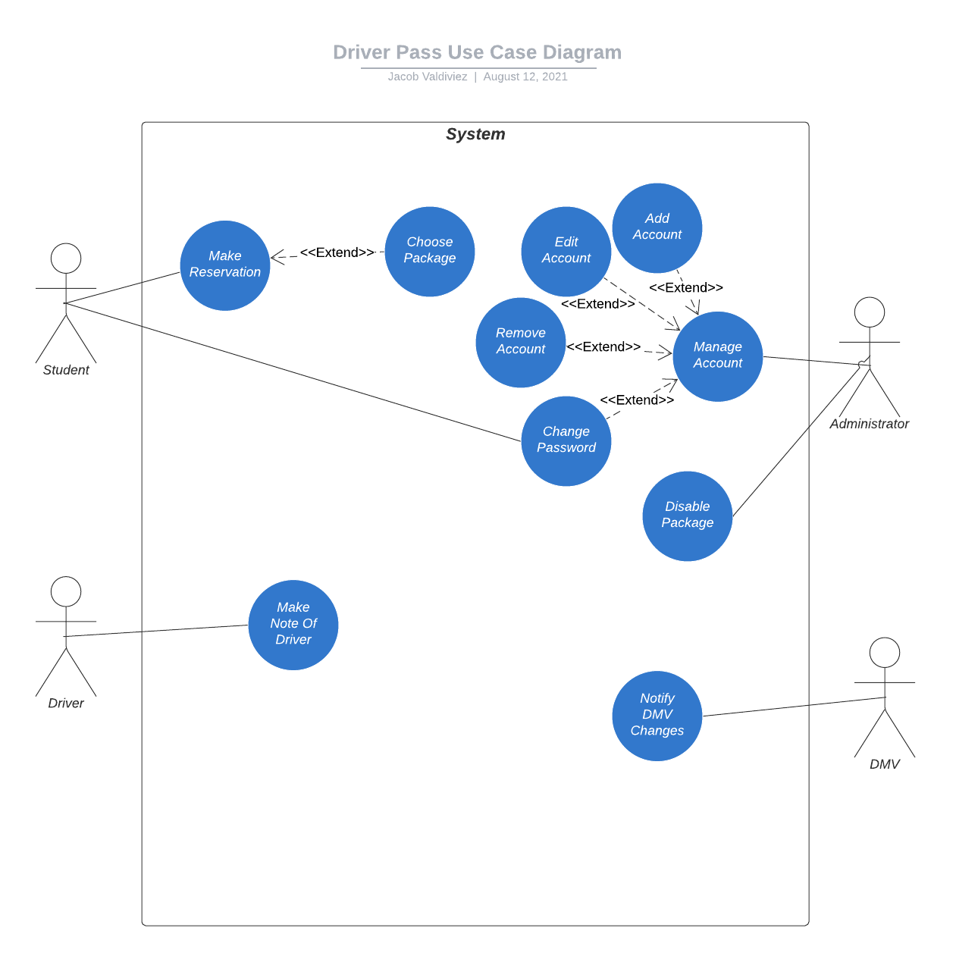

### UML Activity Diagrams

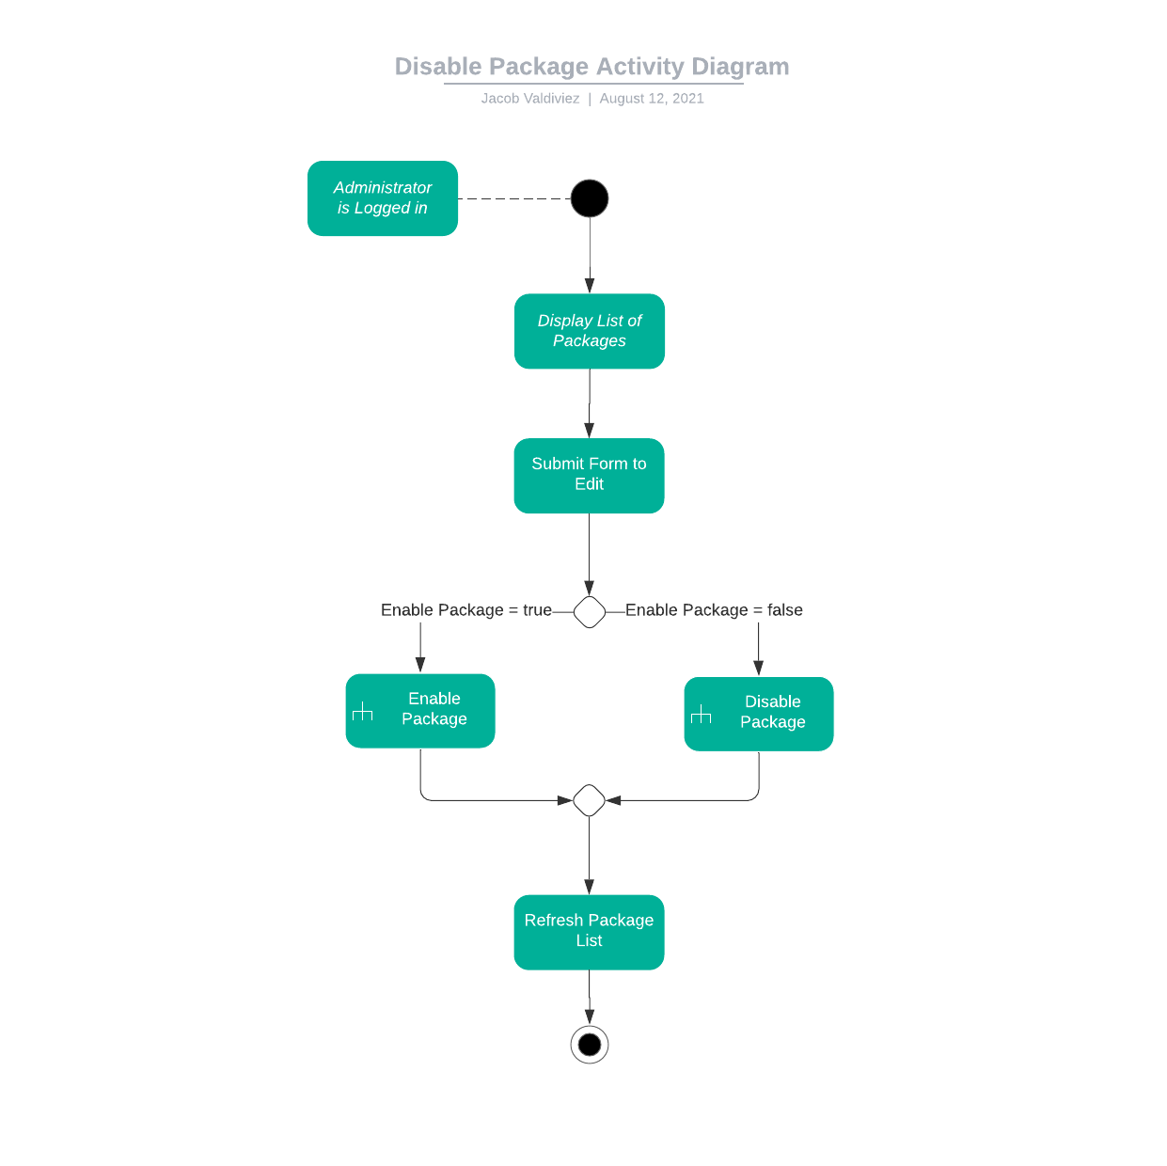

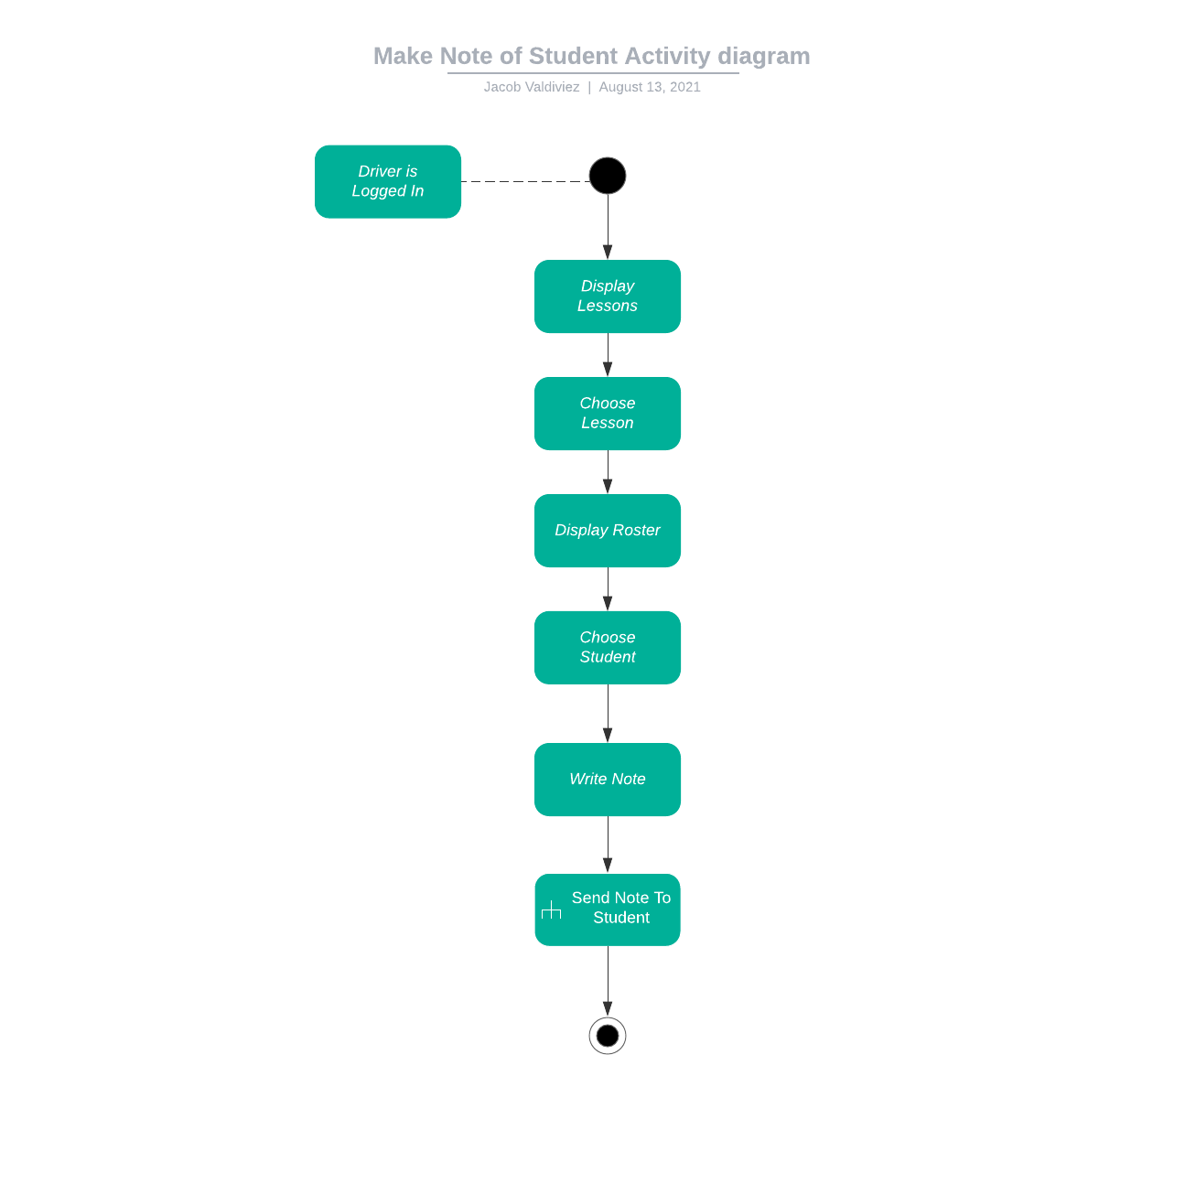

### UML Sequence Diagram

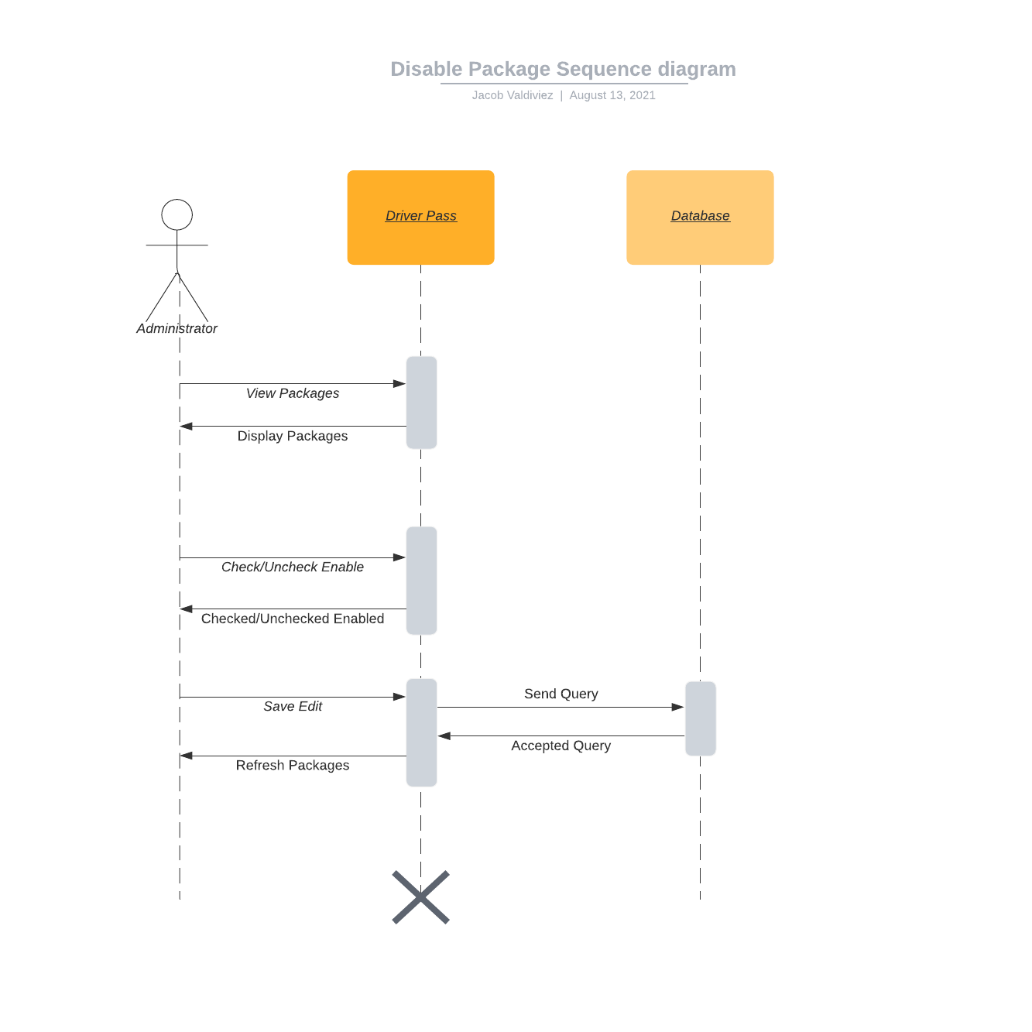

### UML Class Diagram

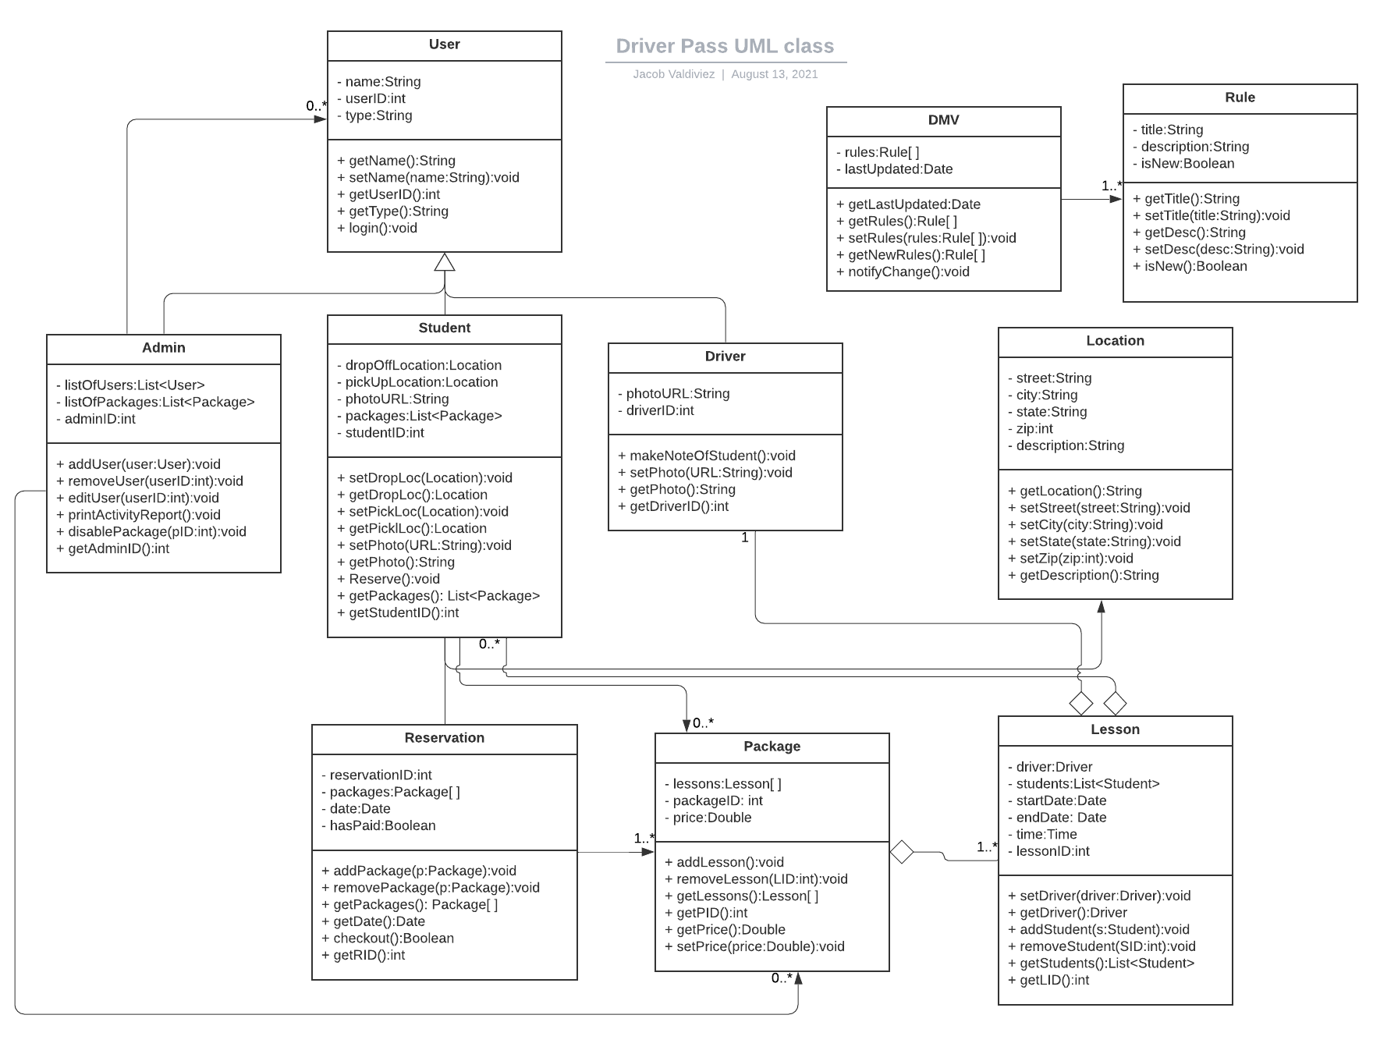

## Technical Requirements

*[Based on the diagrams you have created, describe the technical requirements of your system. These requirements should address the required hardware, software, tools, and infrastructure necessary for your system design.]*

1. *The system shall be developed using web languages including: HTML, CSS, PHP, Javascript, and SQL*
2. *Web development tools shall be used to develop the system: i.e. PhpStorm.*
3. *The cloud shall be accessed by making requests to its API*
4. *A cloud shall be used to store the data of users, authentication, packages, lessons, reservations, and locations.*
5. *The system shall be accessed online by using a browser*
6. *The mobile system shall be developed by using mobile app development languages including: Java, Objective C, Swift and Kotlin.*
7. *Mobile development tools shall be used to develop the mobile system: i.e. Android Studio and XCode.*
8. *The mobile system shall be accessed by using an Android or iPhone mobile device.*